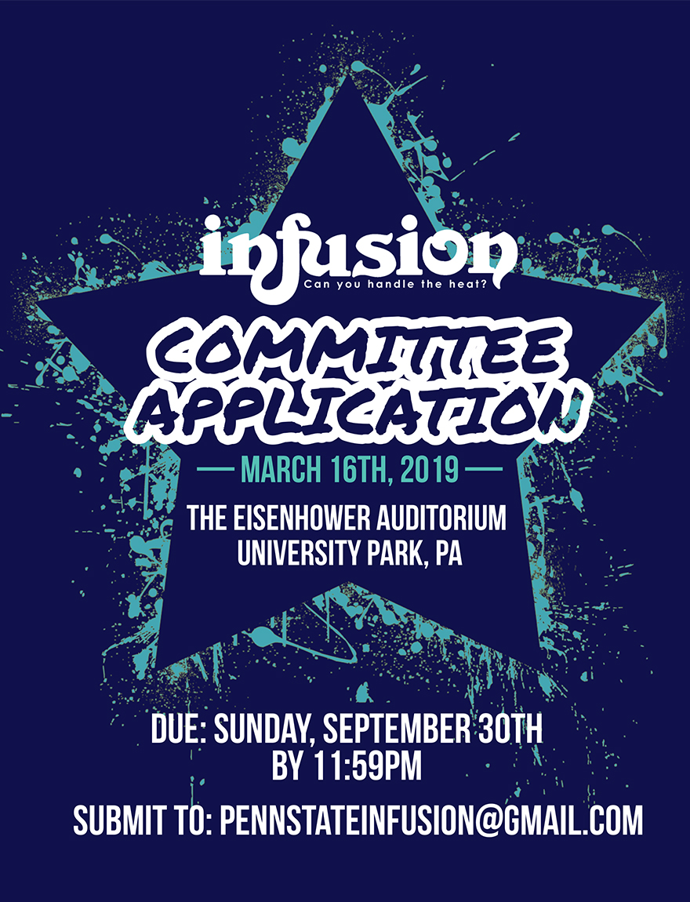

Dear Applicant,

Thank you for your interest in becoming a Penn State Infusion Committee Member! The Infusion Executive Board works hard to create a memorable weekend for 9 collegiate teams that come to Eisenhower Auditorium to compete for $3,000 in cash prizes; however, we cannot fulfill our goal of being one of the most hospitable and entertaining competitions in North America without your help! If you are interested in helping in ways other than being a committee member, please contact us at pennstateinfusion@gmail.com.

How can you become an Infusion Committee Member?
Below you will find a list of the positions we are accepting applications for at this time. Please e-mail your completed application to pennstateinfusion@gmail.com by Sunday, September 30th at 11:59pm. Keep in mind that at this time you may not know all of the answers, but we simply want to see how you would react to different situations. Please answer all questions honestly and without consulting any outside sources. After completing the application, please make sure to save the application with your full name:

(i.e. InfusionCommitteeApplication_Firstname_Lastname.doc).

Do not feel limited in your responses, as the field size will adjust automatically to fit your answer. If, after the interview process, you are chosen as an Infusion committee member, you will sign a commitment contract that will ensure that you agree to fulfill all of your duties in a timely manner. Breach of this contract will result in consequences, and if necessary, the position will be given to another applicant. For any applications with duplicate responses, neither application will be considered for an Infusion Committee position. If you have any questions, please feel free to email us at the email address listed below.

Thank you,
Infusion Executive Board
pennstateinfusion@gmail.com

Liaison:

Each of the 9 competing teams receive two personal team liaisons. As a liaison, you will be the team’s direct contact at Penn State. You will be responsible for making sure the team has minimal difficulties at the competition. Tasks may include (but are not limited to) helping the team deliver their props to Eisenhower Auditorium, delivering meals (provided by Infusion Executive Board) to the team throughout the weekend, guiding the team around campus, and essentially aiding the team in making their weekend at Infusion the most comfortable it can be! It is a truly great way to meet new people and create long-lasting friendships with teams from all over the country. In addition to helping during the weekend of March 15th, 2019, liaisons also help design decorations for the team mixer before the show, partake in various marketing efforts around campus, and decorate a box for their assigned team. The team box is a welcoming gift used to add favors provided by Infusion, and other items you and your partner deem necessary. This is an additional financial obligation dependent upon how much you and your partner are willing to spend.

Community Liaison:

The Community Liaisons are responsible for choreographing and teaching the State College children a Filmi-Fusion dance that will be performed at Infusion. They are also in charge of keeping in contact with the children’s parents and scheduling practice times. They act as the branch between the State College community and Infusion. Also, they are required help design decorations for the team mixer before the show and partake in various marketing efforts around campus.

Technology & Production Manager:

The Technology & Production Team serves as the main contact point between the teams and the Eisenhower staff. This generally includes a pre-production meeting a few months before the competition, a production meeting several weeks before the competition, and other meetings as necessary. The team works with the Registration Directors to obtain all videos, music, and prop lists submitted by the teams and to relay that information to the Eisenhower staff. In addition, the team will work with the Public Relations Directors to create filler videos, flyers, and any other promotional material that needs to be designed. During Infusion weekend, the Production Team coordinates dress rehearsals and ensures that production will meet and exceed team expectations. Also, they are required help design decorations for the team mixer before the show and partake in various marketing efforts around campus.

No design or technical experience is necessary. We will teach you the skills that it takes to run one of the best Filmi-Fusion competitions in North America!

Production Managers will be responsible for:
- Aiding in the design of flyers, videos, and other promotional materials.
- Communicating with teams for lighting cues, music, videos, and props.
- Serving as a liaison between the teams and the Eisenhower staff.
- Executing all stage-related production aspects of the show.

During the weekend of the show, their primary responsibilities will include:
- Working with teams to ensure that all lighting, music, backdrops, etc. meet and exceed the team's expectations.
- Organizing team videos and music to create a seamless show line-up.
- Cuing three teams to their respective stage positions: on stage, on deck (in the loading dock), and in the hole (in the stairway).
- Communicating with the rest of the production team to ensure that the show runs in a fluid and efficient manner.

Hospitality Manager:
The Hospitality Team is essentially the main creative outlet behind Infusion weekend and helps plan an exceptional welcoming and hospitable experience for the teams throughout the weekend.
During Infusion weekend, one of the main tasks assigned to the Hospitality Team will be to set up and run the mixer on Friday, March 15th 2019. The mixer is an extravagant welcome for the teams to the Infusion competition weekend and consists of games, ice-breakers, and creative decorations. Hospitality isn’t all about glitter and hot glue. Creativity and quick-thinking are a great plus!
Hospitality Managers will be responsible for, but will not be limited to, the following:
- Aiding in the creative planning aspects of the mixer and competition
- Leading mixer decoration times at least 4-6 hours/week
- Distributing all meals during the competition weekend

Sponsorship Manager:
Sponsorship Managers are responsible for helping the Sponsorship Directors secure all donations and sponsorship affiliations. Sponsorship Managers assist the Directors to land deals such as monetary donations, meals for the competition weekend, and promotional marketing. The weekend of Infusion, Sponsorship Managers help coordinate food donations and pick up times. This position requires both strong organizational and communication skills. Also, they are required to help design decorations for the team mixer before the show and partake in various marketing efforts around campus.
The Sponsorship Manager will be responsible for:
- Working with local businesses regarding pickup and delivery times for the competition weekend
- Maintaining constant communication with local sponsors in the State College area
- Organizing meals with the Sponsorship Directors for teams during competition weekend

Registration Manager:

The Registration Manager is responsible for helping the Registration Director with the judging and registration process throughout the year. Leading up to Infusion weekend, the registration manager will assist the Registration Directors in searching for and selecting potential qualified candidates to be official Infusion 2019 judges and serve as the bridge between the Infusion 2019 Executive Board and the Official Infusion 2019 judges. The Registration Manager handles all judging forms, logistics, and questions up until and throughout the weekend with the help of the Registration Directors. Being the Judging Coordinator involves being extremely responsible, detail oriented and level headed as you will be primarily dealing with experienced professionals.
Additionally, the registration manager will be expected to monitor liaisons as they communicate with their assigned teams and prepare for Infusion weekend. This entails being the first point of contact between liaisons and the Registration Directors in terms of answering any team related questions or any liaison project issues. The Registration Manager is also required to help design decorations for the team mixer before the show and partake in various efforts around campus.

The Registration Manager will be responsible for:
- Assisting the Registration Directors in selecting all judges along with creating the judging rubric with them
- Maintaining constant communication with the official judges throughout the year and weekend
- Monitoring the entire Infusion 2019 judging process and judges throughout the show in Eisenhower Auditorium
- Keeping track of communication between liaisons and their assigned teams
- Assisting the liaisons in any questions they have regarding their projects or teams
- Helping Registration Directors plan and run a liaison workshop

Place an X next to the position(s) you are applying for (you may apply for more than one):

______ Liaison
______ Community Liaison
______ Technology & Production Manager
______ Hospitality Manager
______ Sponsorship Manager
______ Registration Manager

GENERAL INFORMATION

Name:

Email:

Phone Number:

Academic Year (Highlight): Freshman Sophomore Junior Senior Other

Major:

Gender (Highlight): Male Female

Regardless of your position, we will be asking you to commit your time from Friday, March 15th at 1pm until Sunday, March 17th, 2019. Are you willing to commit to these time requirements for the weekend of the competition?
Yes No

COMPETITION KNOWLEDGE (Highlight)

How many Fusion, Raas/Garba or Bhangra competitions have you attended as a spectator?
More than 10 5-9 1-4 0

How many Fusion, Raas/Garba, or Bhangra competitions have you attended as a competing team member?
More than 10 5-9 1-4 0

Do you feel you have enough knowledge of Fusion dance at this time to help teams feel more comfortable?
Yes No

GENERAL QUESTIONS

What qualities do you feel Infusion committee members need to exhibit? Explain how you possess those qualities.

What do you hope to gain from being an Infusion committee member? Please explain.

THINK OUTSIDE THE BOX (Must pick THREE to respond to)

Describe your personality as a flavor of Penn State Creamery ice cream.

If you were a pizza delivery person, how would you benefit from scissors?

How much does it cost to wash all the windows in State College?

What route would you take to get from the front of Old Main to the Nittany Lion Shrine?

INTERVIEW AVAILABILITY

If selected, interviews will be conducted on the dates listed below. Please list all of the times that you are available.

Monday, October 1st (6:00pm-9:00pm):
Tuesday, October 2nd (6:00pm-11:00pm):
Wednesday, October 3rd (6:00pm-11:00pm):
Thursday, October 4th (6:00pm-11:00pm):

PERSONAL AND PARTNER REVIEW
* only complete if you were a committee member for Infusion 2018. All answers will remain confidential. *

Personal Review:
On a scale of 1-10 (1 being lowest, 10 being highest), rate your performance as a committee member for Infusion 2018 and explain: ______

What do you think you did well?

What could you have done better?

How would you improve Infusion 2019 from what you experienced last year?

